|  |  |
| --- | --- |
| Ex.No:9 | **EVENT REGISTRATION WEB APPLICATION** |
| Date: |

AIM:

To design, develop and deploy a web application for event registration.

ALGORITHM:

Step 1: Create a new frame

Step 2: Select any one present size of your choice

Step 3: Select the shapes you need

Step 4: Import images as needed

Step 5: Create a page you need and link them

Step 6: Validate the HTML and CSS code.

Step 7: Publish the website in the given URL.

PROGRAM:

HTML:

<div style="width: 100%; height: 100%; position: relative; background: #53B98E">

<img style="width: 360px; height: 55px; left: 0px; top: 17px; position: absolute"

 src="https://via.placeholder.com/360x55" />

<div style="width: 224px; height: 71px; left: 60px; top: 361px; position: absolute;

 background: #FF0000"></div>

<div style="width: 224px; height: 71px; left: 60px; top: 462px; position: absolute;

 background: #FF0000"></div>

<div style="width: 165px; height: 33px; left: 116px; top: 379px; position: absolute; color:

 white; font-size: 32px; font-family: Inter; font-weight: 900; word-wrap: breakword">LOGIN</div>

<div style="width: 165px; height: 33px; left: 95px; top: 480px; position: absolute; color:

 white; font-size: 32px; font-family: Inter; font-weight: 900; word-wrap: breakword">REGISTER</div>

<img style="width: 168px; height: 207px; left: 88px; top: 122px; position: absolute"

 src="https://via.placeholder.com/168x207" />

</div>

<div style="width: 100%; height: 100%; position: relative; background: #52D9EB">

<div style="width: 270px; height: 33px; left: 55px; top: 36px; position: absolute; color:

 black; font-size: 24px; font-family: Inter; font-weight: 900; word-wrap: breakword">PONGAL FESTIVAL</div>

<div style="width: 173px; height: 33px; left: 40px; top: 123px; position: absolute; color:

 black; font-size: 18px; font-family: Inter; font-style: italic; font-weight: 300; word-wrap:

 break-word">SINGING</div>

<div style="width: 173px; height: 33px; left: 35px; top: 298px; position: absolute; color:

 black; font-size: 18px; font-family: Inter; font-style: italic; font-weight: 300; word-wrap:

 break-word">MUSIC CHAIR</div>

<div style="width: 173px; height: 33px; left: 35px; top: 348px; position: absolute; color:

 black; font-size: 18px; font-family: Inter; font-style: italic; font-weight: 300; word-wrap:

 break-word">DJ EVENTS</div>

<div style="width: 173px; height: 33px; left: 40px; top: 250px; position: absolute; color:

 black; font-size: 18px; font-family: Inter; font-style: italic; font-weight: 300; word-wrap:

 break-word">KHO KHO</div>

<div style="width: 173px; height: 33px; left: 40px; top: 205px; position: absolute; color:

 black; font-size: 18px; font-family: Inter; font-style: italic; font-weight: 300; word-wrap:

 break-word">KABBADI</div>

 <div style="width: 173px; height: 33px; left: 40px; top: 160px; position: absolute; color:

 black; font-size: 18px; font-family: Inter; font-style: italic; font-weight: 300; word-wrap:

 break-word">DANCING</div>

 <div style="width: 305px; height: 155px; left: 30px; top: 517px; position: absolute; color:

 black; font-size: 32px; font-family: Inter; font-weight: 300; word-wrap: break-word">“May

this festival fill your life with sweetness! peace prosperity, and happiness in your life!” “May

 happiness overflow in your life this year, good luck enter your home and success touch your

 feet.</div>

 </div>

 <div style="width: 100%; height: 100%; color: black; font-size: 16px; font-family: Inter;

 font-weight: 300; word-wrap: break-word">MOBILE NUMBER</div>

OUTPUT:

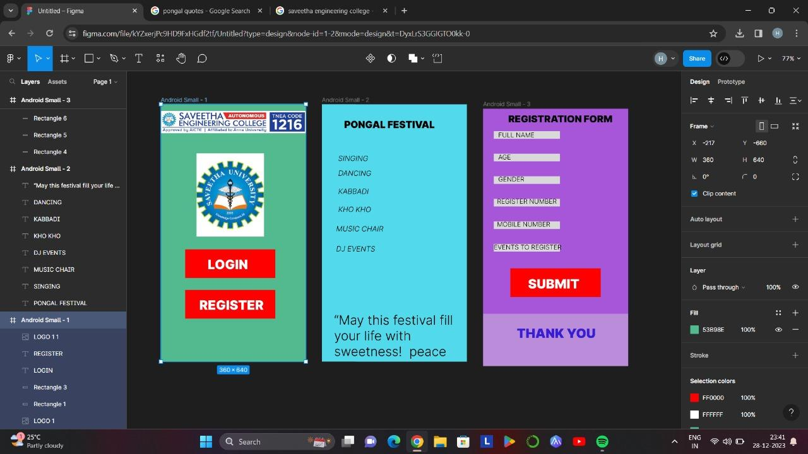

RESULT:

The program to design, develop and deploy a web for event registration is completed

Successfully.